Summary

1. The brief was:
to produce an options paper by March 31 2006 to the Boards of the Canterbury Cricket Association and the Christchurch Suburban Cricket Association on possible competition
formats and club structures. The rationale is to go back to basics and consider what would
be the optimum situation if there was an opportunity to create from the beginning a cricket competition involving all cricketers in the city.

2. The committee first met on January 17 2006 and had regular meetings and email
contacts from that date.

3. Questionnaires were circulated to CCA senior players and CCA premier clubs covering
a wide range of topics.

4. The committee decided to release its options for the future of club cricket in Christchurch
in two parts.

5. The initial report recommends a format for the CCA Premier grade competition and
indicates where the committee is heading in determining the criteria for a Premier grade
club. The latter still requires work and must be viewed as an interim stage only.

6. The second report covering the location of clubs, potential mergers, relationship with
secondary schools and junior cricket, finance and the administration of cricket will be
circulated at a later date.

7. The committee met with representatives of clubs to discuss a draft of the initial report
on Monday, Tuesday and Wednesday March 20, 21 and 22. East Shirley elected to make
their submission in writing and the meeting with the Riccarton club was made by conference
call.

8. Following feedback from those meetings the committee met and revised
its report incorporating some of the comments received. It was circulated to the CCA Board
and CEO Canterbury Cricket prior to a presentation being made to them on Monday
May 1 2006.

9. Recommendations for Premier Grade Cricket
a. that a set of criteria be introduced for a club to achieve premier grade status. It will be
a guide for clubs wishing to enter the premier grade competition and it will be a guide for
the CCA and clubs in monitoring performance against the agreed criteria.

b. that automatic promotion relegation be abolished.

c. that an eight-team premier grade two-day competition be formed and all Christchurch
clubs be invited to enter and that the same eight teams, with the possible addition of some
district or other teams, comprise a premier grade one-day competition. Entries should close
on Monday May 8 2006 and acceptances confirmed by Monday May 29 2006.

d. that the agreed format remain in place for five years with yearly reviews on the format
of the two and one day competitions after three years.

e. that the following format for the CCA premier grade cricket be adopted

Two day cricket

1 One round of two day matches which at the completion of the round robin is split
into a top 4 and bottom 4. 10 rounds allows for 20 days of two day cricket.

Playing conditions
1. 11 am start with 40 minutes for lunch and 20 minutes for tea. 6 hours playing time.
2. Points as presently played, ie 4 points for 1st innings, 10 points for an outright and
the same bonus points system.
3. 100 overs minimum to be bowled in a day
4. 17 overs to be bowled in the last hour.
5. The points achieved by the top four teams in the round robin are carried through to
pool play. The bottom four teams in the round robin will be eliminated from the Premier
Grade competition and will start a new competition with no points carried forward.

One day cricket

1. One round of one day cricket, the competition may include some District teams.
At the conclusion of the round robin the top four teams play off to determine who
goes through to the final.
Ten teams, maximum days of cricket is 11, minimum is 9 days.

20.20 competition
It is recommended that management explore the options for this competition by
further consultation with clubs.
1. Played mid week over the season with dates set by the CCA.

2. All games played over one weekend at one ground

Christchurch Club Cricket Review

Interim Report

1. Introduction
A committee comprising Brian Adams Chairman, Roger Georgieff, Alan Jamieson,
Lindsay Serra, Peter Sharp, Heather Steele and Ivan Thomson was appointed by the Board
of the Canterbury Cricket Association in January 2006 to review Christchurch Club Cricket.

The brief from the Canterbury Cricket Association Board was:
to produce an options paper by March 31 2006 to the Boards of the Canterbury Cricket Association and the Christchurch Suburban Cricket Association on possible competition
formats and club structures. The rationale is to go back to basics and consider what
would be the optimum situation if there was an opportunity to create from the beginning
a cricket competition involving all cricketers in the city.

The committee also noted that the strategic plan under Key Strategy 4 states:
to work with districts and clubs to establish suitable models for the delivery of cricket
that optimizes, resources, facilities, personnel and coaching by 1/10/2007.

A key question that developed early in the discussions was to determine the main
objective of the premier grade competition. The committee agreed that first and second grade
should primarily be targeted at development in a competitive and sustainable structure that is
played on quality pitches and outfields and is both healthy and enjoyable. It was the group’s
belief that neither grade was solely designed to simulate first-class cricket, however if the
“pathway” was there first-class cricketers would naturally emerge.
Accepting that premise the committee worked through a number of key issues, some
relating to the future of the premier grade competition and how it should be structured, some
relating to the future organization of cricket and whether it is in the best interests of cricket to
have two associations administering cricket in the city and some relating to the administration
and location of cricket clubs.
Some of these issues will take time and detailed consultation before they may be
implemented whereas others could be introduced immediately if agreement was obtained.
The committee therefore decided to release for discussion an interim report focusing
solely on the CCA premier grade competition and the criteria required for a club to enter a team
in this competition. This report was released to the six CCA clubs playing in the premier
grade competition and the two CCA clubs playing in the combined competition and
discussed with them in the week beginning March 20. East Shirley opted to make their
submissions in written form while the meeting with the Riccarton club was carried out by
conference call. Following the meetings the committee met to discuss the feedback received
and revised parts of the report incorporating many of the comments received.
During the writing of the draft report the Suburban Cricket Association met
with their senior cricket captains and at an executive committee meeting the next day approved
the adoption of an eight team senior competition for 2006/07 which would combine the points
for the two and one day competition. This decision was not able to be conveyed to the CCA clubs
before meeting with the review committee and in some cases may have influenced their analysis
of the options outlined in the draft report.

A second draft report covering the location of clubs, potential mergers, relationship
with secondary schools and junior cricket, finance and the administration of cricket will be
circulated at a later date using the same approach.

2. History Canterbury Cricket Association
Although cricket had been played in Christchurch from the early days of its settlement
it was not until the Canterbury Cricket Association was formed in 1877 that any semblance of a
competition was created. The formation of an Association was due in part to ensure better
management of Hagley Park and partly to select Canterbury teams. The first true competition
was run in 1882/83 with 4 clubs taking part, United, Midlands, Addington and Lancaster Park. Sydenham was formed when it joined Addington for the 1895/96 season.
In 1905 the pressure to move to a district based scheme such as played in Sydney came
on the CCA. It was claimed it would increase player numbers, promote rivalry between players
and clubs and stimulate interest in the senior competition and the game itself. In July 1905 the
CCA approved the scheme by a vote of 15 to 5. The combined Addington/Sydenham club, the
Lancaster Park club and the United club, only with the votes of its junior members, favoured
the scheme whilst the Midland club voted against it. It was agreed to trial it for two years and
6 clubs were created with United and Midlands going out of existence and Lancaster Park
(Linwood), Sydenham being joined by East Christchurch, West Christchurch, St Albans and
Riccarton.
After two years there was much acrimonious debate lead by the Midland and United
clubs around continuing the scheme and after a number of votes and meetings it was only after
a plebiscite of all current players that district cricket was endorsed by 262 votes to 40. Looking
back now after 100 years one can only admire the courage and foresight of those administrators
in what was undoubtedly a contentious decision. It was not always plain sailing and from the
1911/12 season East and West Christchurch were allowed to select players from outside their boundaries. The CCA made the point that the lack of grounds in the suburbs inhibited the
growth of the sport particularly as most cricket was centered around Hagley Park
(West Christchurch, St Albans and Riccarton), Lancaster Park (East Christchurch and
Lancaster Park) and Sydenham Park.
The district scheme was finally abolished in 1919. In 1927/28 the closed clubs of
HSOB and Old Collegians were admitted to the senior competition, but not without dissension
as they had been playing in the Suburban competition for their first two years of the existence.
The concept of district cricket was again raised at an SGM in 1929 and was approved by 17 to 16.
This move would have excluded HSOB and Old Collegians but at the AGM a month later the
motion was rescinded by 34 to 14. In doing so however it was agreed to confine the CCA to 8
senior clubs and secondary schools, the rest of the clubs would play in the Suburban competition
with the proviso that the most promising Suburban players would transfer to the CCA.
The period after 1940 saw a number of junior clubs joining the CCA and seeking to
enter the senior competition. And although the CCA grappled with this problem for many years
it never really came to a long term decision on how to handle this annual dilemma. Automatic promotion relegation between first and second grade was promoted but then abolished and it
was only after West Old Boys won second grade two years running that the CCA felt the need to arrange a match between them and the bottom placed senior team.
Accordingly in March 1954 a match between East Christchurch and West Old Boys
was played with East winning. The merger between West Christchurch and West Old Boys and University two years later in 1956 had as its main basis the inability of those two junior clubs to
gain senior status. Another junior club, Technical, merged with Lancaster Park prior to the
1982/83 season and that left only one junior club, Marist, playing in the CCA competition.
Marist finally won second grade in 1983/84 and the CCA granted them senior status for the
1984/85 season, a competition which they won. The bye was avoided when the Lancaster Park
club was asked to enter two teams and a 10 team competition was created. However after two
years Lancaster Park declined to continue entering a second team and the bye was only avoided
by the Woolston Mens Working Cricket Club being encouraged to leave the Suburban
Association and enter teams in the CCA. At the beginning of the 1998/99 season WMWC
merged with Lancaster Park and a 9 team senior competition was created.
Concern over the quality of senior cricket lead to another review being undertaken in
2003 which after a number of meetings brought down a recommendation that first grade be
restricted to six teams. The bottom three teams would play in a combined competition with the
senior Suburban clubs and automatic promotion and relegation would take place between the
two grades.
However the merger between HSOB and Old Collegians saw only two CCA clubs taking
part in the combined competition. The CCA board agreed that a review of the playing conditions
would be carried out after one year with the concept being reviewed at the conclusion of the
2005/06 season.

3. Christchurch Suburban Cricket Association:
The formation of a "Thursday Association" was due to many players who had to work
on Saturdays and or preferred to play with their work mates. There was considerable activity in
mid-week cricket and several of these Clubs formed the "Thursday Association" which was
affiliated to CCA
The beginnings of the Suburban Association as we know it today are to be found in
1903/04 and the following summer when somewhat loosely-organised friendly matches were
played on a much more regular basis than previously. These teams were playing their cricket
outside the established Cricket Associations and without being attached or controlled by any
organisation. However, some teams began to consider the idea of arranging a series of matches,
and it was consequently thought timely to create some form of organisation to draw up a
schedule of matches. The idea was mooted by three enthusiastic team captains of forming an Association of Suburban teams.
A series of meetings organised by the Reverend Gray, Minister of the Oxford Baptist
Church, culminated in the forming of the Christchurch City and Suburban Cricket Association in
November 1905. Eight clubs were originally affiliated being Sumner, Oxford Terrace Baptist, Addington Workshops, AJ. White's, Lyttelton, Spreydon and S1 Matthew's Guild. By 1908/09
there were eight Senior and nine Junior teams taking part in competition with 354 players
registered. Sumner is the only club still in existence who played in the first year of the
Association's competition in 1905/1906.
The introduction of One Day International Cricket saw team numbers peak in the
1983/84 season with a record 106 teams. Since then levels have fluctuated around 70 teams
with the current level of 67 CSCA teams affiliated to 31 clubs.
The senior competition has traditionally been an eight team competition. However since
the 2003 review two CCA teams have been playing in a combined competition with the six
"senior" Suburban Clubs and automatic promotion and relegation has taken place between
the top two grades.

4. Playing Results CCA Clubs
One method of determining a club’s success over a period is to take the finishing
position each year and aggregate those points, the lower the points scored the more
successful the team.

Two day Competition.
The two day competition is divided into three periods, the first being the eight team
competition from 1973/74 to 1983/84. The two years 1984/85 and 1985/86 have been
eliminated as this was the period when Lancaster Park entered two teams in first grade.
The second period covers the years from 1987/88 to 1997/98 when there was a
ten team competition with entries from Woolston and Marist and the third period covers
the years between 1998/99 and 2003/04 when Lancaster Park merged with Woolston and
there was a nine team competition.
The first two periods cover eleven years while the third covers six years.
This first period shows a distinct gap between the top and bottom teams with three
clubs Lancaster Park, HSOB and Old Collegians having the most success. Riccarton and
East Shirley were the least successful clubs. East never achieved a placing better than fifth
while Riccarton only showed signs of improvement with a fourth and third in the last two years. Lancaster Park was very much the dominant club and only a last placing in 1983/84 raised
their final score or otherwise they would have come out as being even more successful.
Over the second period both HSOB and Old Collegians fall back quite noticeably
although as the period comes to an end HSOB begins to recover and has two second placings
and a fourth in the final three years. St Albans maintains its success and wins the competition
on six occasions and without a last placing in the 1995/96 season it would have been even
more outstanding. Riccarton makes a large jump from seventh to second and Marist in its first
time in senior cricket performs very well. East Shirley begins its improvement and has a middle
position in most years. A key point of interest is the more even spread of results compared to
the first period and to note that Lancaster Park went from winning the competition in 1996/97
to coming last in 1997/98.
Over the final six year period East Shirley is the big improver while St Albans remained
a leading club. Old Collegians continues to languish at the last position with a sixth placing in
2002/03 its best performance. Sydenham and Burnside were in the bottom third of the
competition in most years with a fourth by Burnside in 2000/01 being its most successful year.
The clear point to note is that club success is cyclical and for most clubs over the 27
years analysed there has been a wide variation in results.

One Day Competition
The first twelve year period is from 1986/87 to 1997/98 and three clubs, East Shirley,
Lancaster Park and Burnside are dominant with the latter club by far the most successful. The
other seven clubs had little success but Riccarton began to make progress and achieved good
results in the last four years winning the competition in the 1997/98 year. The gap between the
clubs is much wider in comparison to the corresponding two day competition period.
The second period covers the years from the merger between LP and WMWCC and
prior to Canterbury Country competing in the one day competition. Burnside makes the greatest
change dropping from first to seventh but the obvious point of interest is to note the continuing
imbalance maintained between the top and bottom clubs.
See appendix 2 page 17

5. Playing Numbers CCA Clubs
Over the 33 year period considered from 1973/74 to 2005/06 the clubs with the
greatest playing numbers remain the same with Lancaster Park Woolston, St Albans, Sydenham, Burnside and East Shirley numerically the strongest. There have been a number of mergers but
in some cases the increased numerical strength seems to disappear after a period of three to
five years.
The entries in women’s cricket covers a shorter period of eight years and the standout
club is St Albans with Burnside, Riccarton, Marist and HSOB making very few entries.
Team entries to junior cricket could only be obtained over the past five years but shows
an even greater spread with Old Collegians, Sydenham, Burnside and East Shirley by far the
strongest CCA clubs. Halswell and Merivale Papanui are the largest Suburban Association clubs entering 16 and 10 teams respectively in 2005/06 with Sumner and New Brighton also having
strong junior sections.
A comparison of men’s team entries from the Canterbury Cricket Association and the Christchurch Suburban Association shows similar trends. High numbers in the late 1980’s with
a significant drop off around 1995/96 with a flattening at around 70 entries since the 2000/01
season.
See appendix 4 page 20

6. Team Performances CCA Premier Grade Cricket
There has been concern over the quality of play in premier grade cricket and whether
a reduction to six teams would raise playing standards. An analysis of the senior competition
was made using such measures as team scores over 200, team scores under 100, number of
results and declarations, number of centuries scored, difference in competition points achieved
and the number of players competing.
A general comment would be that having nine or ten teams in the premier grade
competition has had no discernable influence on the competition. In fact it could be argued that
the better two day cricket was played in the late 1980’s when there were 10 premier teams and
there were more scores over 200 and outright decisions were around 60% of matches.
The change in points over the past six seasons does not seem to have had any influence
on the type of cricket played. eg no first innings points in 2003/04 did not increase the number
of outright results.
The need for declarations, due in part to weather and due in part to the lack of hours to
complete a four innings match, will always be a point for discussion and argument between
players but that is part of the charm of cricket. The percentage of declarations has altered little
over the 20 years.
Of course the quality of play can be influenced by the presence of first class players in
the competition but that is a measure difficult to quantify. For each province there were 45 days
of domestic cricket in 1994/95 dropping to a low of 37 in 1997/98 and rising to 51 days in
2005/06 and when those figures are imposed on club cricket no particular trend shows out.
It is reasonably apparent that for seven years from 1992/93 season there was a noticeable
reduction in scores over 200 which usually leads to more result matches The format of two
day club cricket will always be a compromise between those who favour outright decisions
as a priority and those who favour a close hard competition for first innings points but the
recent player questionnaire, except for a desire to have a semi final in the one day competition, produced a clear mandate for the current playing conditions.
2004/05 and 2005/06 seasons
It is difficult to make an assessment about the six team competition after only two
seasons but the increase in team scores over 200 with a reduction in outright results in 2004/05
was followed by the reverse in 2005/06 where results were up and team scores over 200 down
from 45 to 32. There were nine team scores under 100, an increase from five in 2004/05.
Individual performances also showed significant differences over the two years. In 2005/06
11 players took more than 25 wickets, the highest for the last ten years. Only nine centuries were scored, down from the high of 17 in the 2004/05 season and only three players scored more than
400 runs this past season. In general terms the 2005/06 season was a year where bowlers were
more dominant than the previous year.
See appendix 6 page 23

7. Player Questionnaire Analysed
93 replies were received to a questionnaire circulated to CCA premier grade players in
February 2006. In general there was very good support for the existing playing conditions
with the only change strongly advocated being the introduction of semi finals for the one day
competition. Interestingly there was an almost equal split over the number of premier grade
teams, whether there should be eight or six. The pitches at Garrick Park and Burwood Park
were considered to be the best with the East players rating their ground as very good.
The competition formats produced a wide range of opinion with some support for a
full round of 20.20 cricket, some comments suggesting it could be played mid week.
See appendix 1 page 15

8. Club Questionnaire
Adult subscriptions varied from $185 at Burnside to $225 at Riccarton. Most clubs
had a junior subscription at $50 with a reduction for more than one family member.
The number of persons on an executive committee varied greatly from 6 to 16 but
no club had an unfilled position.
All clubs bar one had a strategic plan and in most cases had been created with the
help of Sport Canterbury.
There was no common position difficult to fill although the President was mentioned
in three cases.
All club houses/pavilions were freehold and no club had plans for expansion other
than Sydenham who have tentative plans with the Sydenham rugby club.
The number of social (closed ) teams varied greatly from nil in two cases to 7 out of
9 with one club.
Most clubs had more than 2 player dressing rooms and separate rooms for umpires
and scorers.
There was general concern over the cutting of the outfields by City Care and the
control by the CCC over outfield watering. These concerns need to be followed up by the
CCA. LPW employ their own groundsman and have no concern.
There was some variation in opinion over the premier grade competition with OBC
labeling it a successful experiment and East, LPW and St Albans stating the standard had
improved. However Riccarton, Sydenham, Marist and Burnside saw little benefit in the six
team competition and made the point that unnecessary pressure was being placed on clubs
resulting in more money and resources being spent on retaining premier grade status.
Other than OBC who were undecided and St Albans who were flexible the remaining
six clubs supported an eight team competition. The proviso was made in two instances that the
higher standard should be maintained.
Concerns raised covered a number of topics but the general theme of difficulty in
attracting and retaining players came through along with too great a reliance on gaming
machine money for income. The inability to find suitable volunteer administrators, the drop
off of players from schools to clubs, the cost, and in particular the variance in cost between
clubs in maintaining quality grounds were all other concerns raised.

9. Playing Days
There is a very apparent trend emerging among many players not only over a reluctance
to play matches on too many Sundays but also to quickly forsake Saturday cricket in favour of
a visit to say a food festival or to a rock concert. There have been a number of defaults in second
and third grade this year, particularly towards the end of the season and such frequency is a cause
for concern.
Many sports seem to have the same problems as cricket in attracting people to join a
club and there would seem to be a proliferation of social “closed” teams in recent years that
often have little interest in club activities. Whether this trend can be reversed is debatable and
may have to be accepted as part of our changing society.
The change was well illustrated by Tony Murdoch who writing in the Riccarton club
history noted “the freeing up of shopping hours, the change in opening and closing hours for
licensed premises, the introduction of student loans, the expansion of concept user pays, the introduction of gaming machines and a percentage of takings going back to the community and
more severe penalties for drink driving were all contributing to the difficulty in attracting players
to play cricket on a regular basis”.
In a normal season there are usually 24 Saturdays available and analysis of the 2006/07
season indicates that will be the norm again. If Labour day, Waitangi day and the Sunday of
Show weekend are utilized then 4 Sundays are required to complete a format that may require
31 playing days. The frequency of Sunday play becomes an even more complicated issue when
an International cricket match is scheduled for a Saturday and if there becomes a desire amongst
players to play the 20.20 competition over a weekend.
See appendix 3 page 19

10. The Present Premier Grade Competition
The committee spent time discussing the format of the CCA premier grade competition,
the effect of automatic promotion relegation on clubs and the difficulty experienced in finding
common playing conditions for the combined CCA/Suburban Senior competition.
They questioned whether the introduction of automatic promotion relegation had been
of benefit in raising the quality of all aspects of a premier grade club and whether simply focusing
on playing standards was in the overall best interests of club cricket in Christchurch. Some clubs
had made the point in their submissions that they believed unnecessary pressure was being placed
on clubs to retain premier grade status and that the money used could be better spent.
The committee took the view that in any automatic promotion relegation system there
was no guarantee that the team being promoted was superior to the team being relegated, that a
playoff between such teams had major disadvantages, particularly with regard to timing, and that
the effect of weather on a competition can distort the true realities, abilities and results for
competing teams.
It therefore did not support the automatic promotion relegation concept being continued.
In coming to this point of view it was also influenced to some extent by the situation in
Sydney grade cricket and the comments of its operation manager Ian Field.
He said that “the Sydney grade competitions had been through similar discussions over
how to raise playing standards and in the past there had been a push from some of the stronger
clubs to reduce the grade to 10 or16 teams from 20. This concept we rejected and as a result we
developed performance criteria for our clubs and over a period of time we found the criteria gap
between the highest and lowest ranked clubs narrowed. We do not believe in annual promotion
and relegation but believe that strong clubs are based on stable volunteer bases, senior player
retention, junior player career paths and retaining sponsors. All these factors could be destabilized
on an annual basis by a club’s concern with promotion and relegation and we believe encouraging
clubs to think only in the short term is not healthy for them or in the long term the NSWCA”.
When making the comments above and the recommendations in the draft paper that was
released to the six CCA clubs playing in the premier grade competition and the two CCA clubs
playing in the combined competition the committee was not aware of the decision that was to be
made by the Suburban Cricket Association in relation to their Senior A competition for the
following seasons.
Their decision to go to an eight team competition that would combine the points from
both the two and one day competitions eliminated the need for discussion on the merits or
otherwise of an automatic promotion relegation system between the premier grade competition
and the combined competition
The committee therefore became more focused on the concept of criteria being produced
that a premier grade club should attempt to achieve and the feedback from one on one meetings
with the clubs was of considerable value for those discussions.
It accepts that some criteria may at this point in time be difficult to achieve but believes
that this approach is of benefit in raising the quality of a premier grade club. It indicates to the clubs
that they not only need to be concerned over the quality of their premier grade team but also must
take an active role in promoting and developing junior, youth and women’s cricket and although it
may give clubs assurance for the future it also places on a club the need to revisit its operation
and administration on a regular basis to ensure it continues to meet those criteria.

11. Meetings With Club Representatives
The meetings with clubs beginning on March 20 were very helpful in clarifying aspects
of the draft report. They gave the committee a very good indication of the degree of acceptance
or otherwise on the options and recommendations proposed.
Six clubs favoured going to an eight team premier grade competition with one club
making the point it would be supportive only if the CCA could make the assurance (as far as
possible) that standards would not fall. The two clubs opposed to the adoption of an eight team competition were concerned over a drop in the quality of play.
One club did not believe that the quality of play should be a significant factor as they
believed achieving and maintaining a strong financial and administrative structure was of far
greater importance. If these were in place a quality premier grade team would follow. They
made the point that over a period of time all clubs have a degree of success.
Six clubs favoured the elimination of automatic promotion/relegation while the
two clubs supporting the concept favoured a play off match played at the end of the season.
The clubs were given two format options for the two day and one day competitions.
Seven clubs supported the recommended option for two day cricket and all eight clubs
supported the recommended option for one day cricket. One club preferred one full round of two
day cricket which would have meant a playing season of between 22 and 25 playing days. They
commented “that players are deliberately supporting fewer playing days especially when you add
in rep trials, under age sides, rep practices etc.. There is a definite view that with family
commitments, work etc. they would prefer little or no cricket on sundays and public holidays
(finals excluded). The view is that this may also help keep some of the players with younger
families in the game”.
There was universal support that the approved format should remain in place for at
least three years, some clubs recommending it stay in place for five years. However all agreed
that the format should be independently reviewed after three years
Seven clubs supported the concept of the adoption of a set of criteria for recognition
as a premier grade club, the one club opposed believing “it was far too prescriptive and touched
on matters that are and should remain for individual clubs to decide. The CCA can set out what
they would wish clubs to provide or achieve but how clubs organize themselves to meet these requirements is for the clubs themselves to decide”.
Most clubs believed that there needed to be a progression on the criteria and these
should be prioritized over a period of three to five years. One queried the need for a third
grade team believing an alternative would be an entry in fourth grade. There was concern
expressed by some clubs regarding the requirement for entries in women’s and junior cricket
and the appointment of a club manager.
Two clubs in particular believed that the CCA should be more active in guiding a
better spread of the playing talent across the club scene and that consideration should be given
to some form of a draft system for talented players coming to the city or coming out of
secondary schools. The Lincoln scholarship scheme was mentioned in this regard.
Some commented on the amount of money spent on producing a strategic plan
and wondered whether a template could be produced by the CCA to simplify the process. Such
a template could also be used for the production of annual accounts.
All clubs were pleased with the transparency of the document and the wide
consultation process that was being undertaken. They looked forward to the second part of the
report.
The committee reviewed the comments received and made a number of changes to
the criteria and to the recommendations.

12. Criteria for Recognition as a Premier Grade Club.
The philosophy behind introducing criteria for a Premier grade club is to ensure that
the clubs not only maintain good playing numbers and competitive teams but also are
strong in administration and finance and look after junior, youth , women’s and men’s cricket.
It also allows the CCA to monitor a club’s progress and identify areas that may need
improvement and in addition any club seeking to enter a team in the Premier grade will know
the criteria required for its application to be successful.
Any club that shows it has met, or is willing to work towards meeting, the criteria will
be invited to apply for entry into the Premier competition where it will remain until it can be
shown that the club no longer meets the criteria
If a club shows that it is failing to meet some of the criteria the CCA management will,
in the first instance, work closely with the club to assist it to meet its obligations.

The number of teams in the Premier competition will be an even number.

12.a Administration
A Premier Club will by 30 September 2006 demonstrate that it has achieved or is working
to achieve the following criteria. It will:-

- be incorporated under the Incorporated Societies Act 1908
- have a constitution that is approved by Canterbury Cricket Association Inc. [CCA] or
any other such organisation that has the responsibility of managing the affairs of
cricket in Christchurch.
- be administered by a Management Committee in accordance with the club’s constitution
- prepare and regularly review a Strategic Plan.
- prepare an Annual Budget
- prepare an Annual Report including an audited Annual Financial Statement in accordance
with the Incorporated Societies Act 1908
- conduct an Annual General Meeting in accordance with the club’s constitution
- actively promote itself, CCA and/or Christchurch Suburban Cricket Association
[CSCA] or any other such cricket organisation as applicable, sponsors, players and cricket
in general through appropriate media
- provide within a reasonable time frame, all reasonable requests for information from CCA
or CSCA or any other such cricket organization, including but not limited to provision
of details of contacts for key personnel, all addresses, register of members, budgets
and annual reports and all other required reports such as umpires, pitch and judicial.
j. comply with all relevant Government and Local body regulations such as liquor
licensing and Health and Safety by laws.
k. work with Sport Canterbury to achieve a Club Award Mark if not already obtained.

A Premier Club will by 30 September 2008 endeavour to:-

l) have in place a club administrator to carry out administrative functions and be designated
as the club’s link with the CCA.
m) have and maintain an up to date web site.

12.b Playing
A Premier Club will by, 30 September 2006, demonstrate that it has achieved or is working
to achieve the following criteria. It will:-

n) appoint a scorer for its Premier Grade team.
o) appoint or designate a manager for its Premier Grade team.
p) prepare and maintain an updated individual or team membership register,
including name, residential and other contact addresses, date of birth and subscription
status of each current playing member
q) provide for the formation of a judiciary process in accordance with the club’s
constitution where necessary to hear any alleged breach of the constitution by a club
member

A Premier Club will by 30 September 2008:-

r) enter teams in the CCA Premier Grade, CCA Second Grade, CCA Third Grade and at
least three other men’s teams in grades conducted by CCA and/or CSCA or any other
such cricket organisation. [Note 1. The expectation is that a Premier club will have
at least 6 men’s teams including at least one in each of the top three competitions. A
club could meet this criterion by having a team in Premier Grade, a team in Secon
Grade, two teams in Third Grade and two other teams. Note 2. School teams entered
by a club in men’s grades are counted as part of the club’s playing obligations on the
basis of 0.5 of a team for each school team entered. So, a club with only 6 teams,
distributed as above, would not meet the criteria if one of those teams was a secondary
school team; it would need to find a 7th team, either adult or school]
s) have at least one team entered in CCA women’s grade competitions

12.c Development and Coaching
A Premier Club will by 30 September 2006 demonstrate that it has achieved or is working
to achieve the following criteria. It will:-

t) appoint a Club Coach who will be available to all members free of charge.
u) appoint a Coach for its Premier Grade team and endeavour to have a coach for
teams in other grades

A Premier Club will by 30 September 2007:-

w) have a written working relationship/agreement with at least two schools, one of which
shall be a secondary school, the agreement covering such aspects as coaching,
practice facilities and a liaison that encourages school leavers to join a cricket
club.

x) enter at least one secondary school age team in a youth competition.
y) enter at least 6 teams, boys, girls or mixed, in the local Christchurch Junior Cricket
Association’s CJCA] or equivalent competitions

12.d Facilities
A Premier Club will by 30 September 2006:-

z) provide a pitch for every 2 teams entered in men’s or women’s CCA or CSCA competitions
aa) prepare for each days’ play, pitches and outfields to a standard that is as high as could
reasonably be expected for the level of such competition
bb) provide at the highest possible standard sufficient turf and/or artificial practice facilities for
all club practices
cc) provide effective pitch covers at all grounds for matches where covers are required by
CCA or CSCA or any other such cricket organisation regulations
dd) provide a scoreboard for each match
ee) provide clearly defined boundary markings at each ground
ff) provide changing facilities, including toilets and showers, for players and umpires wherever
Premier Grade cricket is played
gg) provide suitable accommodation for scorers wherever Premier Grade cricket is played
hh) provide acceptable facilities for the preparation and serving of lunches and afternoon teas
and on-field drinks wherever Premier Grade Cricket is played
ii) provide seating for players
jj) provide first aid materials and equipment, including access to a mobile phone, at each
ground and to a standard that is required by CCA or CSCA or any other such cricket
organisation that conducts the cricket competition(s).

12.e General

kk) If a club’s playing performance is considered to be below an acceptable level over three
consecutive years the CCA management will work closely with the club to improve the
quality of play before it is considered ineligible to remain in the premier grade competition.

13. Recommendations for CCA Premier Grade Competitions
In making the following recommendations the committee is conscious that at present
some teams may not be fully competitive and that over any time period some clubs are very
successful while others struggle to be competitive. A competitive imbalance between teams is
a reality in any competition and in any sport and the difficulty is deciding the most appropriate
manner in which to create an even contest. There is clearly no benefit to any sport at the premier
level to have a wide range of abilities between competing teams and in general this competitive
imbalance changes over a period of time with most clubs having a period of success.
The committee makes the recommendations for the two day competition in the belief
that it would allow the opportunity to improve the quality of those less competitive teams
without the negative aspects of a automatic promotion relegation scheme affecting their ability
to either attract or retain quality players.
The 20 days of cricket that would be available is the same as currently being played
in the six team competition.
The committee believes it is important that the second grade competition format is
identical to the premier grade as far as it is practical and recommends that it comprises the
same eight teams as entered in the premier grade competition. Entries from non premier grade
clubs would be considered on merit but a bye should be avoided.
The format recommended for the one day competition has strong support and the
number of entries depends on the interest shown by the District Association. The CCA strategic
plan clearly wishes to involve the District Associations in the delivery of cricket and the
committee would recommend that entries from them for the one day competition be assessed
on a year to year basis.
If both recommendations are adopted a maximum of 31 days or a minimum 29 days
of cricket, assuming a10 team one day competition, would be necessary.

Recommendations
Two day cricket
1. One round of two day matches which at the completion of the round robin is split
into a top 4 and bottom 4. 10 rounds allows for 20 days of two day cricket.

Playing conditions
1. 11 am start with 40 minutes for lunch and 20 minutes for tea. 6 hours playing time.
2. Points as presently played, ie 4 points for 1st innings, 10 points for an outright and
the same bonus points system.
3. 100 overs minimum to be bowled in a day
4. 17 overs to be bowled in the last hour.
5. The points achieved by the top four teams in the round robin are carried through to
pool play. The bottom four teams in the round robin will be eliminated from the Premier
Grade competition and will start a new competition with no points carried forward.

One day cricket
1. One round of one day cricket, the competition may include some District teams.
At the conclusion of the round robin the top four teams play off to determine who
goes through to the final.
Ten teams, maximum days of cricket is 11, minimum is 9 days.

20.20 competition
It is recommended that management explore the options for this competition by
further consultation with clubs.
1. Played mid week over the season with dates set by the CCA.

2. All games played over a weekend at one ground

APPENDIX 1
Player Questionnaire Analysed.
1. Start of Play 2. Luncheon Interval
11am 48% 40 minutes 57%
10.30am 29% 35 minutes 7%%
10am 12% 30 minutes 36%
10.45am 8%

3. Tea Interval
20 minutes 78%
15 minutes 22%

4. Points
First innings Outright
4 52% 10 57%
5 19% 12 21%

Points Split
4/10 33%
4/12 15%
5/10 14%

5. Bonus Points
Yes 91%
No 9%
Majority view was to keep the present bonus points system.

6. Compulsory 100 overs in a day
Yes 90%
No 10%

7. Overs bowled in last hour
17 58%
20 13%
18 12%
16 10%
15 5%

8. One day semi finals
Yes 99%
No 1%

9. Number of teams in Premier grade
Eight 53%
Six 47%

10. Promotion/ relegation
Yes 70%
No 30%

11. Eight team competition
1 round of two day, one day and 20.20 44% 30 days
2 rounds two day, 1 round one day 30% 37 days
1 round two day, 2 rounds one day 26% 30 days

12. Six team competition
2 rounds two day, 1 round one day, 20.20 33% 32 days
1 round two day, 2 rounds one, 1 round 20.20 27% 32 days
2 rounds two day, 1 round one day 20% 27 days
2 rounds two day, 2 rounds one day 20% 32 days

13. Pitch Ratings
Rated best pitch played on
Burwood 32
Garrick Park 32
Hagley 3 19
Rangiora 2
Middleton 1
Hagley 1 1

Home pitch rated
St Albans on Hagley 1
Good 1
Average 8
Poor 3

Riccarton on Hagley 3
Very good 6
Good 6
Poor 1

Burnside
Good 5
Average 7
Poor 2

Sydenham
Good 7
Average 2

LPW 5
Very good 5

Marist
Good 4
Average 4
Poor 4

East
Very good 10
Good 2

OBC
Good 6
Average 3
Poor 1
Split answers indicated Elmwood good and getting better
Hagley 1 average to poor.

Overall summary of pitch ratings
Very good 21 (24%) Good 31 (36%) Average 24 (27%) Poor 11 (13%)

APPENDIX 2
Playing Results 1973/7 to 2004/05

1. Two day Competition
Graph 1
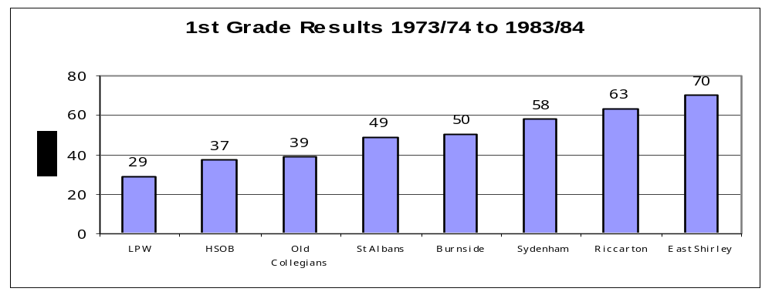
This eleven year period shows a distinct gap between the top and bottom teams with three
clubs very successful. Riccarton and East Shirley are the least successful clubs. East never
achieved a placing better than fifth while Riccarton only showed signs of improvement
with a fourth and third in the last two years. Lancaster Park was very much the dominant club
and only an eight and last placing in 1983/84 raised their final score or otherwise they would
have come out as being even more successful.

Graph 2
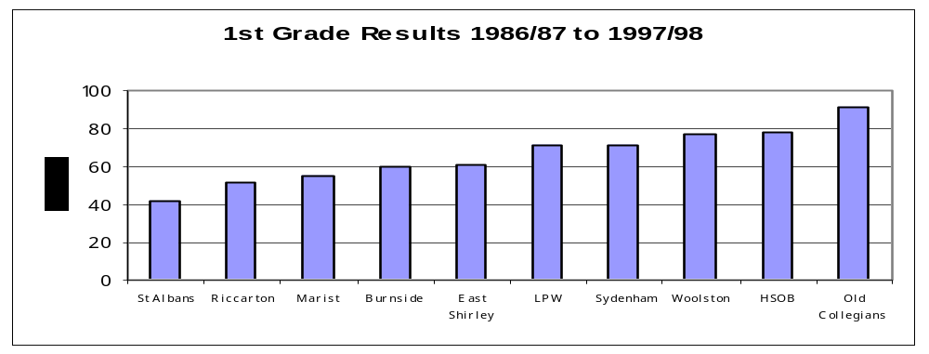
Over this twelve year period both HSOB and Old Collegians fall back quite noticeably
although as the period comes to an end HSOB begins to recover and has two second
placings and a fourth in the final three years. St Albans maintains its success and wins
the competition on six occasions and without a last placing in the 1995/96 season it would
have been even more outstanding. Riccarton makes a large jump from seventh to and
Marist in its first time in senior cricket performs very well. East Shirley begins its
improvement and has a middle position in most years. A key point of interest is the
more even spread of results compared to the first period particularly between clubs
Lancaster Park, Sydenham,Woolston and HSOB. Also of interest is to note that Lancaster
Park went from winning the competition in 1996/97 to coming last in 1997/98.

Graph 3.
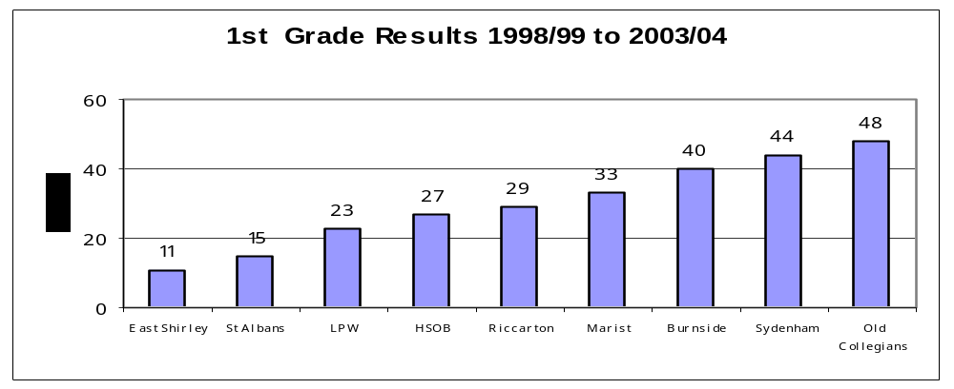
Over this six year period East Shirley is the big improver while St Albans remained a
leading club. Old Collegians continues to languish at the last position with a sixth placing
in 2002/03 its best performance. Sydenham and Burnside were in the bottom third of the
competition in most years with a fourth by Burnside in 2000/01 being its most successful year.

One day Competition

Graph 1
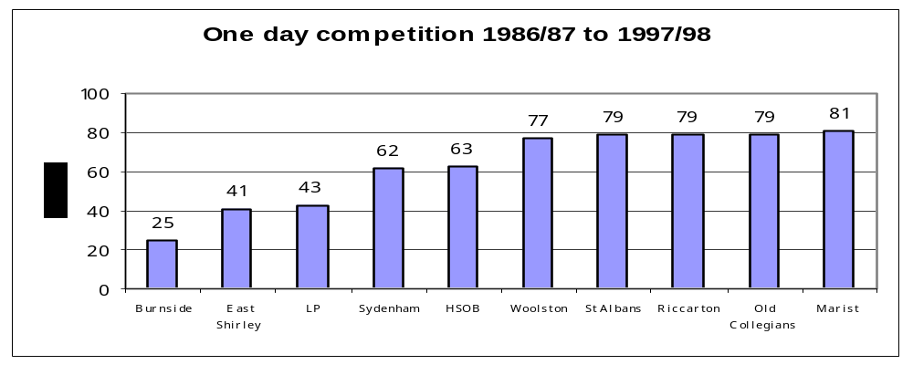
Three clubs dominate this twelve year period with Burnside by far the most successful.
The other seven clubs had little success but Riccarton began to make progress and
achieved good results in the last four years winning the competition in the 1997/98 year.

Graph 2
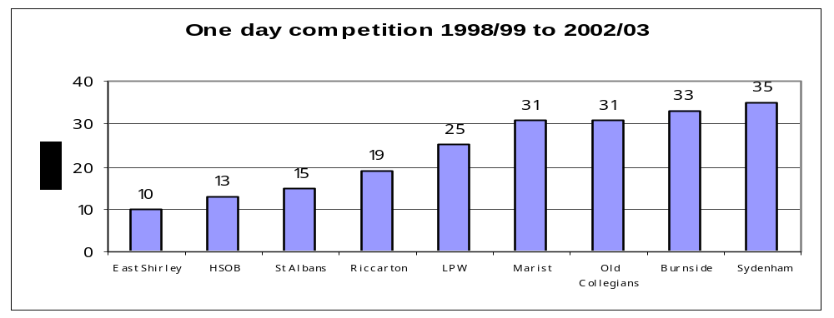
This covers the five year period after the merger between LP and WMWCC and prior to
Canterbury Country competing in the one day competition. Burnside makes the greatest
change dropping from first to seventh but the obvious point of interest is to note the
imbalance continuing between the top and bottom clubs.

Appendix 3
Playing Days
 | Teams | 2 day rounds | Days | 1 day rounds | Days | max/min days | Start time 2 day | Playing hours
1976/77 | 8 | 11 | 22 |  |  | 22 | 10.45am | 12.5 hrs
1977/78 | 8 | 11 | 22 |  |  | 22 | 10.45am | 12.5 hrs
1978/79 | 8 | 11 | 22 |  |  | 22 | 10.45am | 12.5 hrs
1979/80 | 8 | 10 | 23 |  |  | 23 | 10.30am | 13 hrs
1980/81 | 8 | 10 | 23 |  |  | 23 | 10.30am | 13 hrs
1981/82 | 8 | 10 | 20 | 4 | 4 | 24 | 10.30am | 13 hrs
1982/83 | 8 | 10 | 20 | 4 | 4 | 24 | 10.30am | 13 hrs
1983/84 | 8 | 10 | 20 | 4 | 4 | 24 | 10.30am | 13 hrs
1984/85 | 10 | 9 | 18 | 9 | 9 | 27 | 10.30am | 13 hrs
1985/86 | 10 | 9 | 18 | 9 | 9 | 27 | 10.30am | 13 hrs
1986/87 | 10 | 9 | 18 | 9 | 9 | 27 | 10.30am | 13 hrs
1987/88 | 10 | 9 | 18 | 9 | 9 | 27 | 10am | 14 hrs
1988/89 | 10 | 9 | 18 | 9 | 9 | 27 | 10am | 14 hrs
1989/90 | 10 | 9 | 18 | 9 | 9 | 27 | 10am | 14 hrs
1990/91 | 10 | 9 | 18 | 9 | 9 | 27 | 10am | 14 hrs
1991/92 | 10 | 9 | 18 | 9 | 9 | 27 | 10am | 14 hrs
1992/93 | 10 | 9 | 18 | 9 | 9 | 27 | 10.30am | 13 hrs
1993/94 | 10 | 9 | 18 | 9 +sf+f | 11 | 29/27 | 10.30am | 13 hrs
1994/95 | 10 | 9 | 18 | 9 +sf+f | 11 | 29/27 | 10.30am | 13 hrs
1995/96 | 10 | 9 | 18 | 9 +sf+1+f | 12 | 35/28 | 10.30am | 13 hrs
1996/97 | 10 | 9 | 18 | 9 +sf+1+f | 12 | 35/28 | 10.30am | 13 hrs
1997/98 | 10 | 9 | 18 | 9 +sf+1+f | 12 | 35/28 | 10.30am | 13 hrs
1998/99 | 9 | 8 | 16 | 8 +sf+1+f | 11 | 32/25 | 10.30am | 13 hrs
1999/00 | 9 | 8 | 16 | 8 +sf+1+f | 11 | 32/25 | 11.30am | 12 hrs
2000/01 | 9 | 8 | 16 | 8 +sf+1+f | 11 | 32/25 | 10.30am | 13 hrs
2001/02 | 9 | 8 | 16 | 8 +sf+1+f | 11 | 27/24 | 10.30am | 13 hrs
2002/03 | 9 | 8 | 16 | 8 +1 | 9 | 25/24 | noon | 12 hrs
2003/04 | 9 | 8 | 16 | 9+1 | 10 | 26/25 | 11am | 12 hrs
2004/05 | 6 | 10 | 20 | 9+1 | 10 | 30/29 | 11am | 12 hrs
2005/06 | 6 | 10 | 20 | 9+1 | 10 | 33/31 | 11am | 12.20 min

Canterbury Country entered one day competition in 2003/04
Press Knock Out played fro 6 seasons from 1995/96
20.20 competition played 2005/06

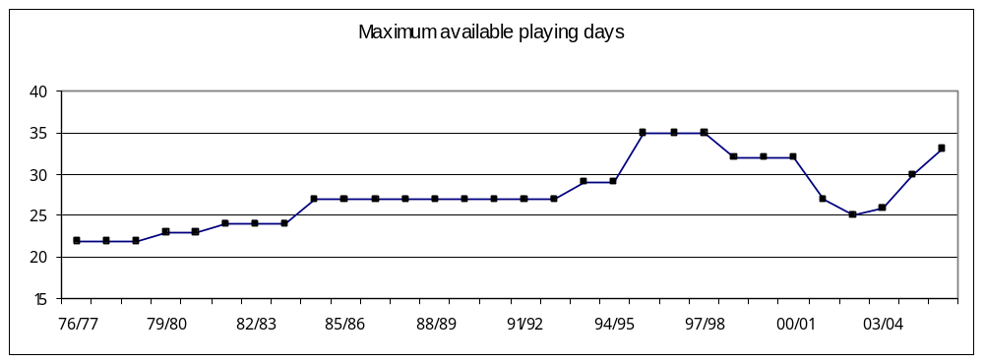 In a normal season there are usually 24 Saturdays available and analysis of the 2006/07
season indicates that will be the norm again. If Labour day, Waitangi day and the Sunday of
Show weekend are utilized then 2 Sundays are required to complete a format that may require
29 playing days.

Appendix 4
Team Entries
Graph 1.
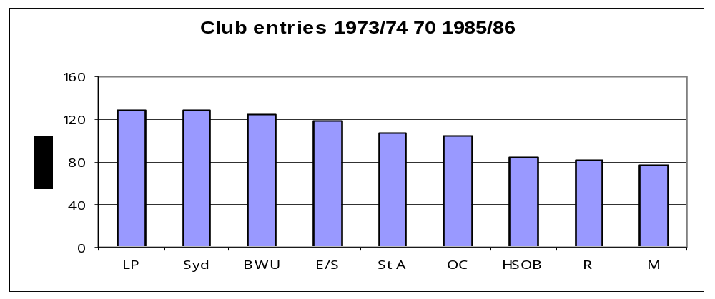
This graph covers a 13 year period up until the Woolston Working Mens Cricket Club
joined the CCA.
Graph 2.
Club entries 1986/87 to 1997/98
0
40
80
120
160
LP
St A
Syd
E/S
HSOB
M
BWU
OC
R
W
This covers a 12 year period up until the Woolston WMCC merged with Lancaster Park.

Graph 3.
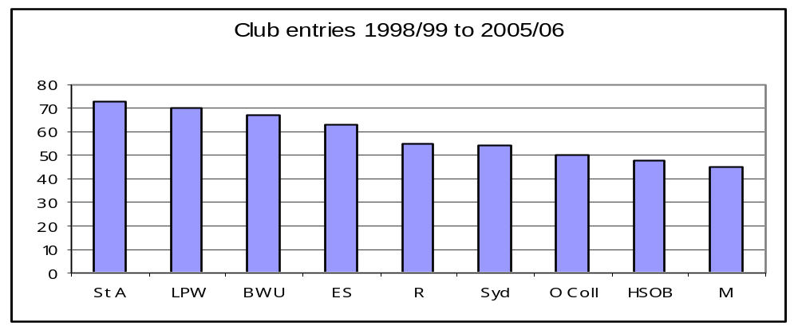
This covers the final eight period. Over the 33 year period clubs with the greatest playing
numbers remain the same with Lancaster Park Woolston, St Albans, Sydenham, Burnside
and East numerically the strongest.

Graph 4.
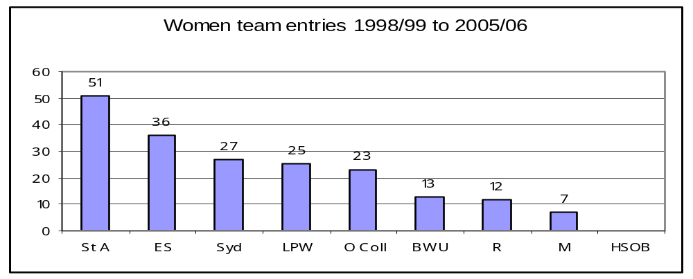

Graph 5.
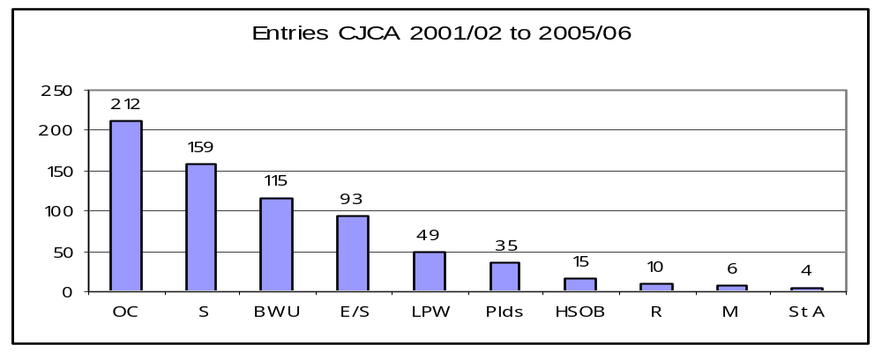
This graph shows the number of teams entered from the CCA clubs over the last five years.
Team entries covering earlier periods were not available.
Some clubs organize a Friday night competition among themselves and those numbers
are not included in the figures above.

Graph 6
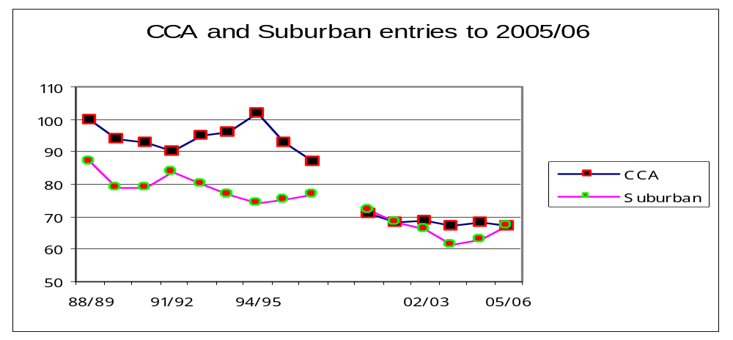
This graph compares team entries from the two Associations over two periods.
The first period is from 1988/89 to 1996/97 and the second period from 2000/01 to 2005/06.
It shows a significant drop around 1995/96 with a flattening off at around 70 entries from
2000/01.

Graph 7
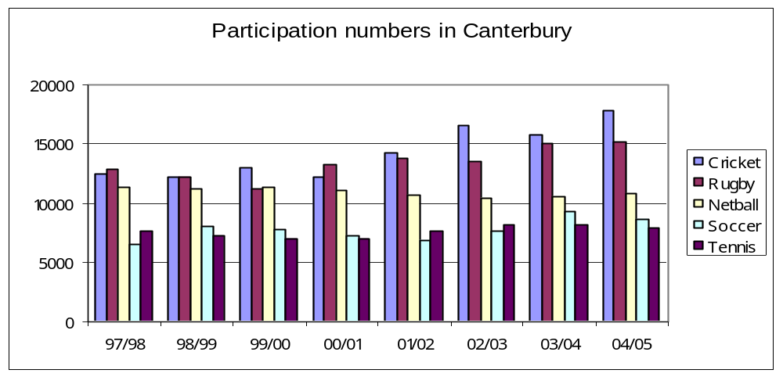
These figures were supplied by Sport Canterbury and compared participation numbers over a
variety of sports. Cricket compares very well with other sports.

Appendix 5
Points Structure CCA Premier Grade Cricket
99/00 to 01/02
1st innings 6
outright 12
bonus in 1st 60 overs at 150, 190,230 runs
at 5,7, 9 wkts
03/04 points
1st innings nil
outright 12
bonus 0.01/run batting
0.20/wkt bowling
win by inns or 10 wkts 3
win by 100 runs or 7 wkts 2

04/05 points
1st innings 2
outright 10
bonus 0.01/run batting
0.20/wkt bowling
win by inns or 10 wkts 3

Appendix 6
Team Performances Premier Grade Competition
Two day cricket
Graph 1.
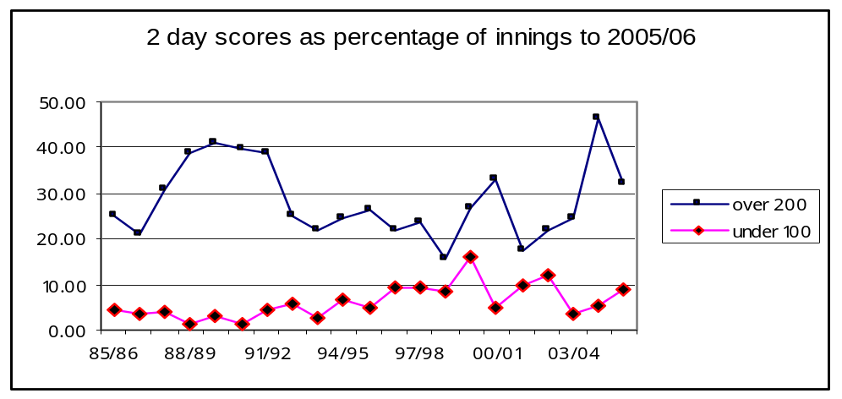
This graph shows the comparison of scores over 200 and under 100. Ideally the gap
between the lines should be as wide as possible which would indicate frequent high scores
and few low scores. The gap is at its widest around the 1989/90 season when there 10 teams
in the premier grade competition. It closed up during a seven year period from 1996/97 when
the competition had nine teams but widened again in 2003/04 and 2004/05 seasons. The
2005/06 season shows that scores over 200 are down and scores under 100 have increased.

Graph 2.
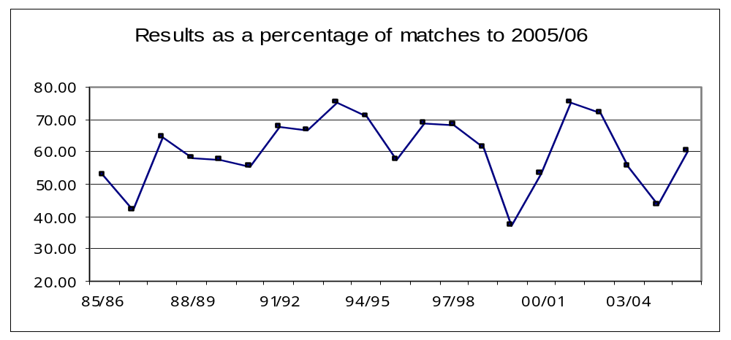
The most outright decisions were achieved in the 2001/02 season but since that year
the number of decisions have declined until this past season.. In general the number is around
60% of matches but the two years 2003/04 and 2004/05 saw a rapid decline. More scores
over 200 in 2004/05 may have been a reason but possibly a wet season and concern with the introduction of a six team competition could have been a contributing factors for 2003/04. The
2005/06 season saw more results and back to the 60% level.

Graph 3.
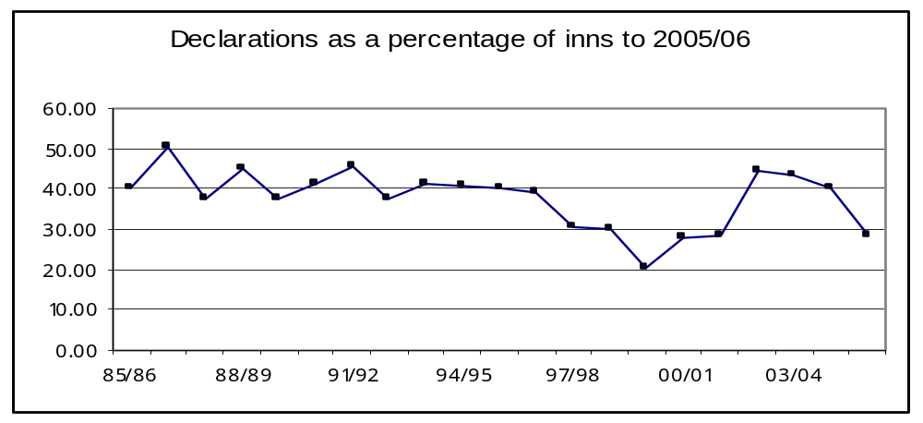
The percentage of declarations have remained constant at around 40% of innings
except for a five year period when the number dropped to as low as 20% in 1999/00.
This trend may have reflected a situation where results were obtained without the need for
declarations. The past three seasons have seen the number of declarations fall with quite a significant drop this past season to 28%

Graph 4.
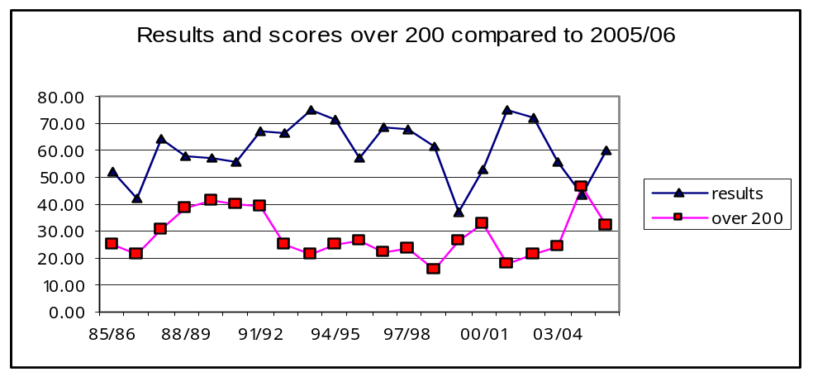
Not surprisingly when scores over 200 are reduced the ratio of outright decisions rises.

Graph 5.
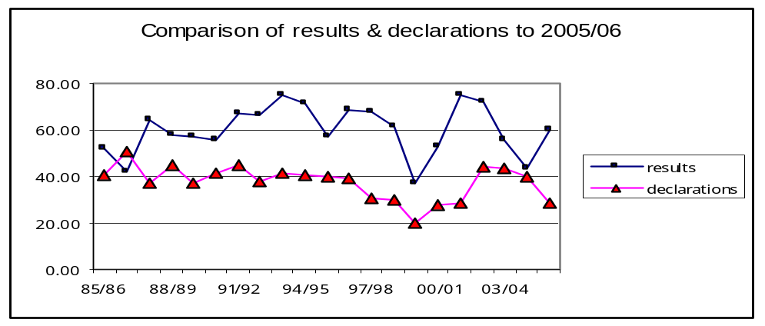
No apparent difference in trends over the period except for two seasons,
2003/04 and 2004/05 where the numbers are much closer. The 2005/06 season saw
the gap widen appreciably.

One Day Cricket
Graph 6.
One day scores as % of innings to 2005/06

0.00
10.00
20.00
30.00
40.00
50.00
85/86
88/89
91/92
94/95
97/98
00/01
03/04
Over 200
Under 100
No apparent trend except to note the considerable variation in numbers from the 1996/97
season. Although scores over 200 vary greatly the general trend is around 27% of innings.
The variation may reflect a wet season or the effect of the toss and the quality of the team
batting first.

Graph 7.
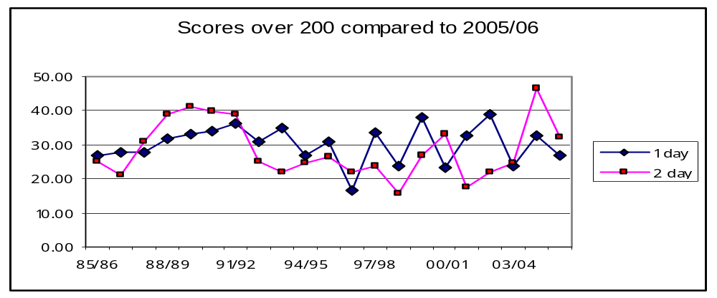
This graph compares scores over 200 in both the two and one day competitions.
In 11 of the 20 seasons more scores over 200 are achieved in the one day competition.

Graph 8.
One day scores compared
0.00
20.00
40.00
60.00
80.00
85/86
88/89
91/92
94/95
97/98
00/01
03/04
shield
club
This graph compares scores over 200 in domestic cricket with club cricket. Up until the
1993/94 season there was a similarity in numbers but since that time, except for 2002/03
season, scores over 200 have been more frequent in domestic cricket. The percentage at
around 27% has not changed greatly over the period for club cricket indicating no strong
improvement in batting.

Competition Points Achieved Premier Grade Cricket
Graph 9
Competition points difference as a percentage to 2005/06
0.00%
20.00%
40.00%
60.00%
80.00%
100.00%
60/61
65/66
71/72
76/77
81/82
86/87
91/92
96/97
01/02
The graph takes the difference in points achieved by the leading and bottom placed teams
in the Premier grade competition over a 45 year period and reflects that point difference
as a percentage against the points scored by the leading team.
eg 1973/74 leading team 155 points
bottom team 78 points
difference 77 points
as a percentage 49.68%
The difference was less from around 1970 through to 1982, became higher through the 90’s
and had been falling in 2003/04 and 2004/5. The difference rose in 2005/06 and almost
reached 70%.
Bottom placed team over 45 years.
Old Colls 11 East 8 Sydenham 7
Lancaster Park 5 Burnside 3 HSOB 3
Riccarton 2 St Albans 2 Marist 2
Woolston WMCC 1
Lancaster Park 2 2
Note Marist, Woolston WMCC and Lancaster Park 2 only competed for 22, 12 and 2 years respectively.

Appendix 7
Individual Performances Premier Grade Cricket
Graph 1
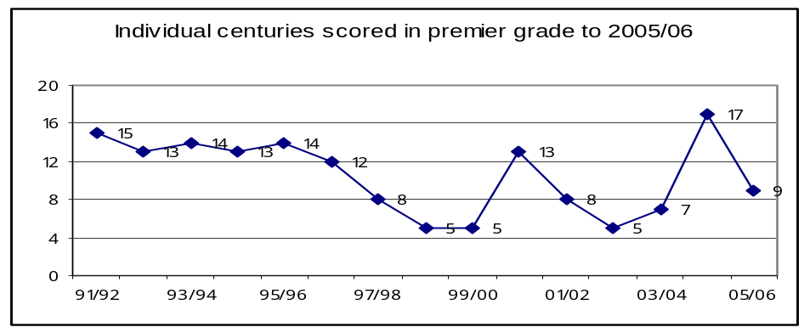
This shows the total number of centuries scored in a season in two day cricket.
17 scored in 2004/05 was the highest in the last 15 years, dropping back to 9
this past season.

Graph 2.
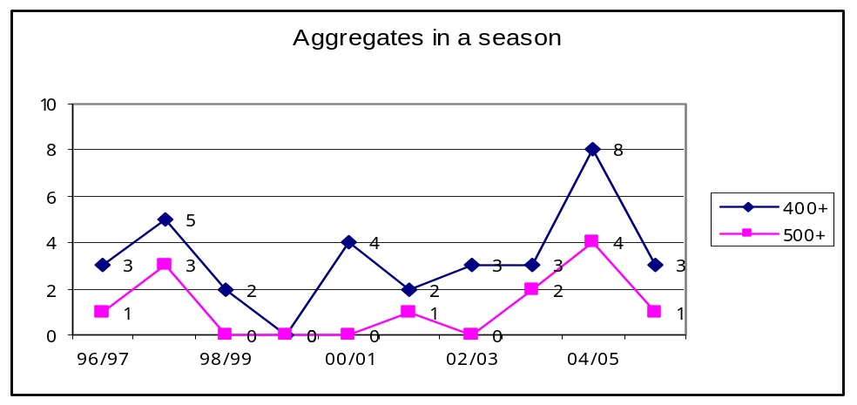
This shows the number of players scoring more than 500 runs and 400 runs in a season
from 1996/97 to 2005/06. The number of playing days can effect this statistic but the
8 players scoring more than 400 runs in 2004/05 is quite significant but falling back
to 3 for 2005/06.

Graph 3.
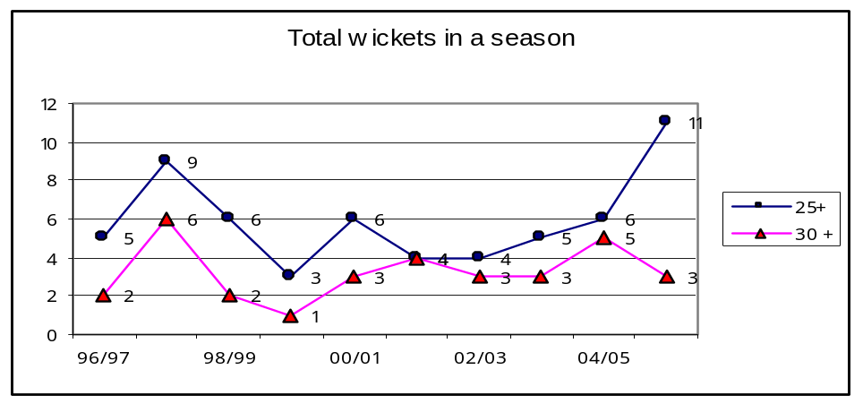
This shows the number of players taking more than 30 wickets and 25 wickets in a season
from 1996/97 to 2005/06. Similar comments as applied to Graph 3 but not a great variation
in numbers over the ten years analysed until this past season when there were a large number
of players taking more than 25 wickets.

Graph 5
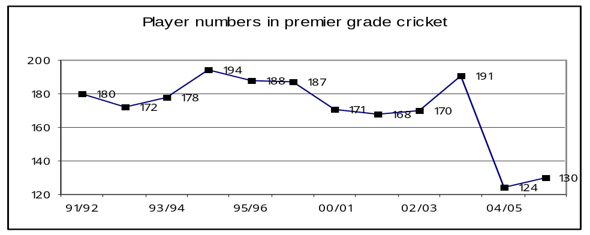
This graph shows the total number of players playing in the two day competition over
two different six year periods. There were ten teams in the first period from 1991/92,
down to nine teams from 2000/01. It is distorted somewhat by a very large number of
players used by HSOB and Old Colls in 2003/04 season

Appendix 8
Premier Grade Cricket Questionnaire

As part of the comprehensive review of Christchurch Club cricket that is at present being
undertaken the committee is keen to have the views of current senior players on a number of
topics. The results from this survey will be a key element in the final options paper produced
for the Boards of the CCA and the CSCA and will be the basis for decisions made on future
competition formats.
Feedback from players is important and we appreciate the time taken to fill in the paper.
Brian Adams
Chairman

Club

1. Hours of Play
Please indicate which of the following options you would support. Option________

a. 10am to 12.30am 1.10pm to 3.30pm 3.50pm to 6pm 7hrs/day
b. 10.30am to 1pm 1.30pm to 3.30pm 3.50pm to 6pm 6hrs 40min/day
c. 10.45am to 1pm 1.30pm to 3.30pm 3.50pm to 6pm 6hrs 25min/day
d. 11am to 1pm 1.30pm to 3.30pm 3.50pm to 6pm 6hrs 10min/day
e. Noon to 3pm 3.20pm 6.30pm 6hrs 10min/day
f. 11.30am to 2.30pm 3pm to 6pm 6hrs/day
g. 11.50am to 1.50pm 2.20pm to 4.20pm 4.40pm to 6.40pm 6hrs/day

2. How long should the lunch interval be?
(Please circle one of the options)
40 minutes 35 minutes 30 minutes

3. How long should the tea interval be?
(Please circle one of the options)
20 minutes 15 minutes

4. Points structure
How many do you prefer?
1st innings_______________
Outright_____________
Bonus points yes no
If yes: how many_________________

5. Over rates
Should the compulsory 100 overs in a day currently in use be maintained?
(Please circle one of the options)
yes no

6. How many overs should be bowled in the last hour of a 2 day match?
(Please circle one of the options)
20 overs 19overs 18overs 17 overs 16overs 15 overs

7. Would you like to see semi finals introduced into the one day competition?
(Please circle one of the options)
yes no

8. Over the season how do you rate your home premier grade pitch?
(Please circle one of the options)
excellent very good good average poor very poor

9. Which premier grade pitch is the best you have played on?________________________

10. How many teams should play in the premier grade competition?
(Please circle one of the options)
eight six

11. Do you believe that promotion/relegation is a good concept?
(Please circle one of the options)
yes no

12. What format would you prefer for an 8 team competition? Option________
a. 2 rounds of two day cricket
1 round of one day cricket + final/and semi final 36/37 days cricket
b. 1 round of two day cricket
2 rounds of one day cricket + final/and semi final 29/30 days cricket
c. 1 round of two day cricket
1 round of one day cricket + final/and semi final
1 round of 20.20 cricket. 29/30 days cricket

13. What format would you prefer for a 6 team competition? Option________
a. 2 rounds of two day cricket
1 round of one day cricket + final/and semi final 26/27 days cricket
b. 2 rounds of two day cricket
2 rounds of one day cricket + final/and semi final 31/32 days cricket
c. 2 rounds of two day cricket
1 round of one day cricket + final/and semi final
1 round of 20.20 cricket. 31/32 days cricket

d. 1 round of two day cricket
2 rounds of one day cricket + final/and semi final
1 round of 20.20 cricket. 31/32 days cricket

Club Cricket Review Questionnaire

1. Club
2. Contact names responsible for completion of the questionnaire.

Contact 1
Phone
Day_________________

Night________________

Mobile_______________

Email address________________________________________

Contact 2
Phone
Day_________________

Night________________

Mobile_______________

Email address________________________________________

Contact 3
Phone
Day_________________

Night________________

Mobile_______________

Email address________________________________________

3. Social (closed) teams
How many teams does your club have in this category?__________________

4. Subscription:
Adult Male:______________ Adult Female_______________

Secondary School:_________________________

Primary/Intermediate School:_________________

Concessional rates:_________________________

5. Administration:
How many elected executive committee members does your club have?____________

Are there any unfilled positions?______________

Which position is the hardest to fill?_____________________

Do you have a separate committee to run junior cricket;_________________________

Does the junior section have a separate accounting system?______________________

Does the club have a written strategic plan? If so please attach:

Over the past ten years has your club considered or discussed a possible merger with another
club? If so briefly outline the proposal and the reasons for the failure.
______________________________________________________________________
______________________________________________________________________
______________________________________________________________________

6. Club Facilities:
Is your club house freehold?______________________

If it is mortgaged what amount is owing?_____________________________________

______________________________________________________________________

______________________________________________________________________

If the building is rented outline the terms and who owns the building:_______________

______________________________________________________________________

Are there plans to extend or improve it? If so briefly outline the plans and cost_______

______________________________________________________________________

______________________________________________________________________

Do you have a current lease for the land? If so when does it expire?________________

How many separate player changing rooms are available?_________________

Do you have a separate changing room for umpires?_____________________

Do you have a separate room for scorers?______________________________

How many match pitches are available on the premier grade block___________________

Does a winter sport play over the main pitch block?_______________________________

Do you have any match or practice artificial pitches? If so how many and indicate their condition:
_____________________________________________________________________________

Does the main block have an automatic irrigation system. If so who controls this:____________

_____________________________________________________________________________

Does the outfield for the main wicket block have an automatic irrigation system? If so who controls it?

_____________________________________________________________________________

Who cuts the outfield and what concerns do you have with this arrangement?________________

______________________________________________________________________________

Are you able to provide minimum boundaries of 54 metres for all matches on the main block?___

Do you have a sightscreen for the main block?_____________________________________

How many covers do you own? Indicate their approximate size and condition:____________

___________________________________________________________________________

7. Junior Cricket:

Outline any specific concerns you may have:___________________________________
________________________________________________________________________

________________________________________________________________________
________________________________________________________________________

8. Secondary School Cricket:

Outline the extent of your clubs involvement with any secondary school:______________
_______________________________________________________________________
_______________________________________________________________________

_______________________________________________________________________

9. Club Cricket:

What is your opinion of the premier grade competition played over the past 2 years?____

_______________________________________________________________________

_______________________________________________________________________

How many teams should play in the premier grade competition?____________________

Do you support promotion and relegation?______________________________

What are your clubs greatest concerns and how might they be improved:_____________
_______________________________________________________________________
_______________________________________________________________________

_______________________________________________________________________

_______________________________________________________________________

Outline your vision for the future of club cricket:________________________________

_______________________________________________________________________
_______________________________________________________________________

Are there any other comments you wish to make for the committee to consider:________

_______________________________________________________________________

_______________________________________________________________________
If there are any questions or queries that you may have relating to this questionnaire then please do not hesitate to contact any member of the review committee. The committee thanks you for taking the time to complete this questionnaire and asks that it be completed and returned to the CCA office no later than:
Monday 13 February 2006.

